POLICY: Open Access Admissions Policy

PURPOSE:
This procedure describes the admissions process from the enquiry stage through to admissions. Admissions are the first point of contact with prospective learners, it is imperative that we provide outstanding customer service, ensuring that we are efficient and professional with the information, advice and guidance that we provide.

SCOPE:
This procedure applies to course enquiries and course admissions onto full time and part time programmes and apprenticeships. Specific processes for Admission to Higher Education programmes are outlined in part 7.

PROCEDURE:

- Enquiries

  - Enquiries can be in person within the College premises, at offsite events, over the phone or via the website. Staff taking enquiries will provide dates of Open Events as appropriate.

  - Initial advice and guidance will be provided for all course enquiries.

  - Upon receipt of an enquiry related to a course, the prospective learner's details are recorded on Pro-Solution. As a minimum the following details need to be captured; Contact name (including surname), contact telephone number, age to determine course cost, address (if information pack required), nature of course enquiry including whether full time, part time or Apprenticeship.

  - Where course information is requested, the prospective learner will be invited to an Open Event and/or an Information Pack will be sent out for the area of interest; these may include course information, an application form, a prospectus or Bursary application pack.

  - If the prospective learner (non-School leaver) is interested in an Apprenticeship they are transferred to the Commercial Team; name and contact details will be forwarded with the enquiry.

  - Where the prospective learner is unsure about the course then they will be invited to an Open Event and/or refer them back to their school Careers Advisor.

  - Where the course is not available, then the prospective learner will be invited to an Open Event and/or an appointment will be made with a Careers Advisor.

- 16-19 (19-24 with an EHCP) Admissions Process

  - For all 16-19 full time courses, an application is required. For any applicant up to the age of 24 with an EHCP in place will follow the same pathway as an applicant age 16-19. 19+ adults applying for 16-18 full-time courses where infill is allowed will be dealt with by the same procedures as given below.

  - The Admissions team receive dates of Open Events from the Marketing team. Open Events take place throughout the year and are a time when many applications are received from new applicants.
  - Applications are received in either paper form or in electronic form via the Online Applications system.

  - Upon receipt of an application form, the applicant details are recorded on Pro-Solution (application stage).

  - Applicants for Apprenticeships will be forwarded to the Commercial Team to support with finding an Employer and invited to an Apprenticeship Workshop as part of the Interview Stage. They will also be offered a Full-time provision for a course in a similar course as a back-up should they not gain a suitable Employer.

  - Where it is clear the applicant is unsure about the course, or the course would be unsuitable for the applicant an appointment will be made with a Careers Advisor.

  - Applicants will be sent a letter/e-mail within 5 working days of their application inviting them to an interview (Interview Stage).

  - At interview, curriculum teams staff can give a formal offer of a place along with an acceptance form which the applicant can sign at interview or can telephone/e-mail Admissions to accept the place offered to them.

  - Formal offers are subject to the applicant meeting any specific entry criteria, which may include GCSE grades, clear DBS check etc. The exact course place offered will be determined generally by the expected/achieved qualifications, but could also take into account prior qualifications in a related subject, English/Maths assessment results etc.

  - Where a disability and/or learning/support needs are identified on an application form all the relevant information is to be referred to the Learning Support Team. The Learning Support Team will contact the applicant to arrange assessment and support where needed and/or liaise with the subject tutor.

  - Where criminal convictions are disclosed the Admissions Team will ensure the applicant competes a Form A for courses covered by the Rehabilitation of Offenders Act (ROA), or Form B for exemptions (Child care and Health & Social Care) and refer the learner to the Safeguarding team, who will carry out a risk assessment and advise as to whether or not a place can be offered, following the Managing Learner Disclosure Procedure.

  - Where the applicant is over the age of 19 and does not have an EHCP, this is highlighted as there may be a cost implication on entry.

  - Pro-Solution is updated by the Admissions team to reflect the outcomes, and a report is available on Pro-Solution for Heads of Learning which shows the current status of all applicants – whether they have been offered a place, accepted an offer, withdrawn, referred to another programme or enrolled.

  - All full time applicants are ‘kept warm’ through the year by Marketing mailings/Facebook group, and will be invited to attend ‘Taster Sessions’ throughout the academic year and a ‘Find your Feet’ session in the summer when they will meet staff, fellow students and get a taste of their course. These sessions provide an opportunity for the College to assess the appropriateness of a course for the learner, and for the learner to determine whether the course is right for them prior to it starting formally.
  - All applicants who have been offered a place will receive information regarding their CANVAS account.

  - All offered applicants will be invited into a main enrolment event following GCSE results day to confirm their course and complete enrolment. GCSE results will determine whether or not the course originally offered is still the right one for the applicant.

  - Please see Appendix 1 for the Admissions process flowchart for the above steps.
- Adult Admissions Process

  - Where a course has set entry requirements then an application form will be required for 19+ programmes. For 19+ courses without entry requirements, applicants enrol in-person at college without the need for the procedures below.

  - Admissions staff receive dates and times of Open Events and Interview dates from Heads of Learning and Marketing.

  - Applications are received either in paper form or in electric form via the Online Applications system.

  - Upon receipt of the application form, the applicant details are recorded on Pro-Solution (application stage).

  - Applicants for Apprenticeships will be forwarded to the Commercial Team to support with finding an Employer.

  - Where a disability and/or learning/support needs are identified on an application form all the relevant information is to be referred to the Learning Support Team. The Learning Support Team will contact the applicant to arrange assessment and support where needed and/or liaise with the subject tutor.

  - Where criminal convictions are disclosed the Admissions Team will ensure the applicant competes a Form A for courses covered by the Rehabilitation of Offenders Act (ROA), or Form B for exemptions (Child care and Health & Social Care) and refer the learner to the Safeguarding team, who will carry out a risk assessment and advise as to whether or not a place can be offered, following the Managing Learner Disclosure Procedure.

  - Where an interview is required, applicants will be sent a letter/e-mail with an invitation to attend an informal course interview. This could be face-to-face/telephone or online.

  - Prior to an informal interview the Admissions team inform Reception of the date of the interview and provide them with a list of names and times of applicants that have been invited. They will also be given the information of the location of the interviews and/or the member of staff that will be collecting the applicants from Reception. As the applicant is over the age of 19, it is highlighted that there may be a cost implication on entry. The curriculum staff who are conducting the interview will be given the relevant interview paperwork including an interview schedule and the course the person has applied for.

  - Following the informal course interview, the interview schedules and documents are returned to the Admissions team and they update Pro-Solution with the outcome. A report is available on Pro-Solution for Heads of Learning which shows the status of all applicants – whether they have attended the informal interview, been offered a place, accepted, withdrawn, referred to another programme or enrolled.

  - If the programme is not suitable for the applicant, the Tutors will either offer the applicant another programme/level within the same Programme Area or redirect them to Admissions or Careers for further information, advice and guidance on alternatives.

  - Applicants who do not attend their initial informal course interview are automatically invited into the next available session. If they fail to attend a second time they are contacted before being withdrawn from the process.

  - Please see Appendix 2 for the Admissions process flowchart for the above steps.

- Main Enrolment

  - Please refer to and follow the Enrolment Procedure.

- Marketing

  - Marketing campaigns will be used to ensure that prospective learners and applicants are kept engaged with the College through a series of marketing campaigns, these may include for example;
- Invites to College Open Events
- Parent / Guardian Information
- Website and prospectus information

- Refusal of Places

  - A place may be refused owing to the disclosure of previous conviction/cautions, the Vice Principal will write to the applicant to confirm the outcome in these cases. Where a place is refused for any other reason, it is the responsibility of the relevant Curriculum area to communicate with the applicant.

- Admission to Higher Education Programmes

  - Full time applicants make applications through UCAS to the appropriate deadlines. Part time applications are made directly to Staffordshire University through their web site. All applications are recorded by the University’s Central Admissions team and inputted into SITs/e: vision which is remotely accessed by all partnership organisations.

  - The College’s Admissions team is notified by a automated e-mail notification of new and outstanding applications. All applications are then recorded onto Pro-Solution.

  - Part time applications for Education courses are forwarded to the College via e: vision from Staffordshire University. Applications are forwarded to the College’s Admissions team, a decision is made regarding the application. The College processes the application on e:vision. The letters to the student are then sent out by the University.

  - Full time applications are forwarded by the University admissions team to the relevant School within the University where a decision is made regarding the application. The letters to the student are then sent out by the University. The college receives the information regarding outcomes via e:vision.
  - Applications are assessed on programme entry criteria, personal statements and by interview where applicable.

  - If UCAS (via the university) notifies the College Admissions team of the detection of plagiarism in personal statements, the College reserves the right to decline the application or withdraw any offers made.

  - Full-time and part-time students are able to apply for Disabled Students’ Allowances (information and application forms at the link): https://www.gov.uk/disabled-students-allowances-dsas

  - The college organises the support for the students and once a student is identified as being eligible for Disabled Students’ Allowance they are invited to arrange an assessment of their support needs and can be referred to the local assessment centre webpage link: https://www.staffs.ac.uk/study/disabled/access_centre
Criminal convictions which are disclosed on application or during interview will be referred to the Safeguarding team who will carry out a risk assessment and advise as to whether or not a programme place can be offered.

  - Course Leaders communicate all outcomes for their groups to the College’s Admissions team and enrolments are inputted into Pro-solution. All outcomes are communicated to the student by the University.

  - For Staffordshire University programmes, university guidelines on admissions will be followed. The admissions process for all higher education provision is informed by the UK Quality Code Chapter B2.

  - The College welcomes applications from those from non-standard and non-traditional backgrounds as part of its widening participation agenda and to increase the higher-level skills profile of the local and wider community.

  - Feedback on the admissions process, appeals against offer decisions and complaints are dealt with initially through the university’s procedures, which will refer them through to the College for investigation and reporting back to the university.

  - Please see Appendix 3 for the HE Admissions process flowchart for the above steps.

Appendix 1: 16-19 Admissions process flowchart
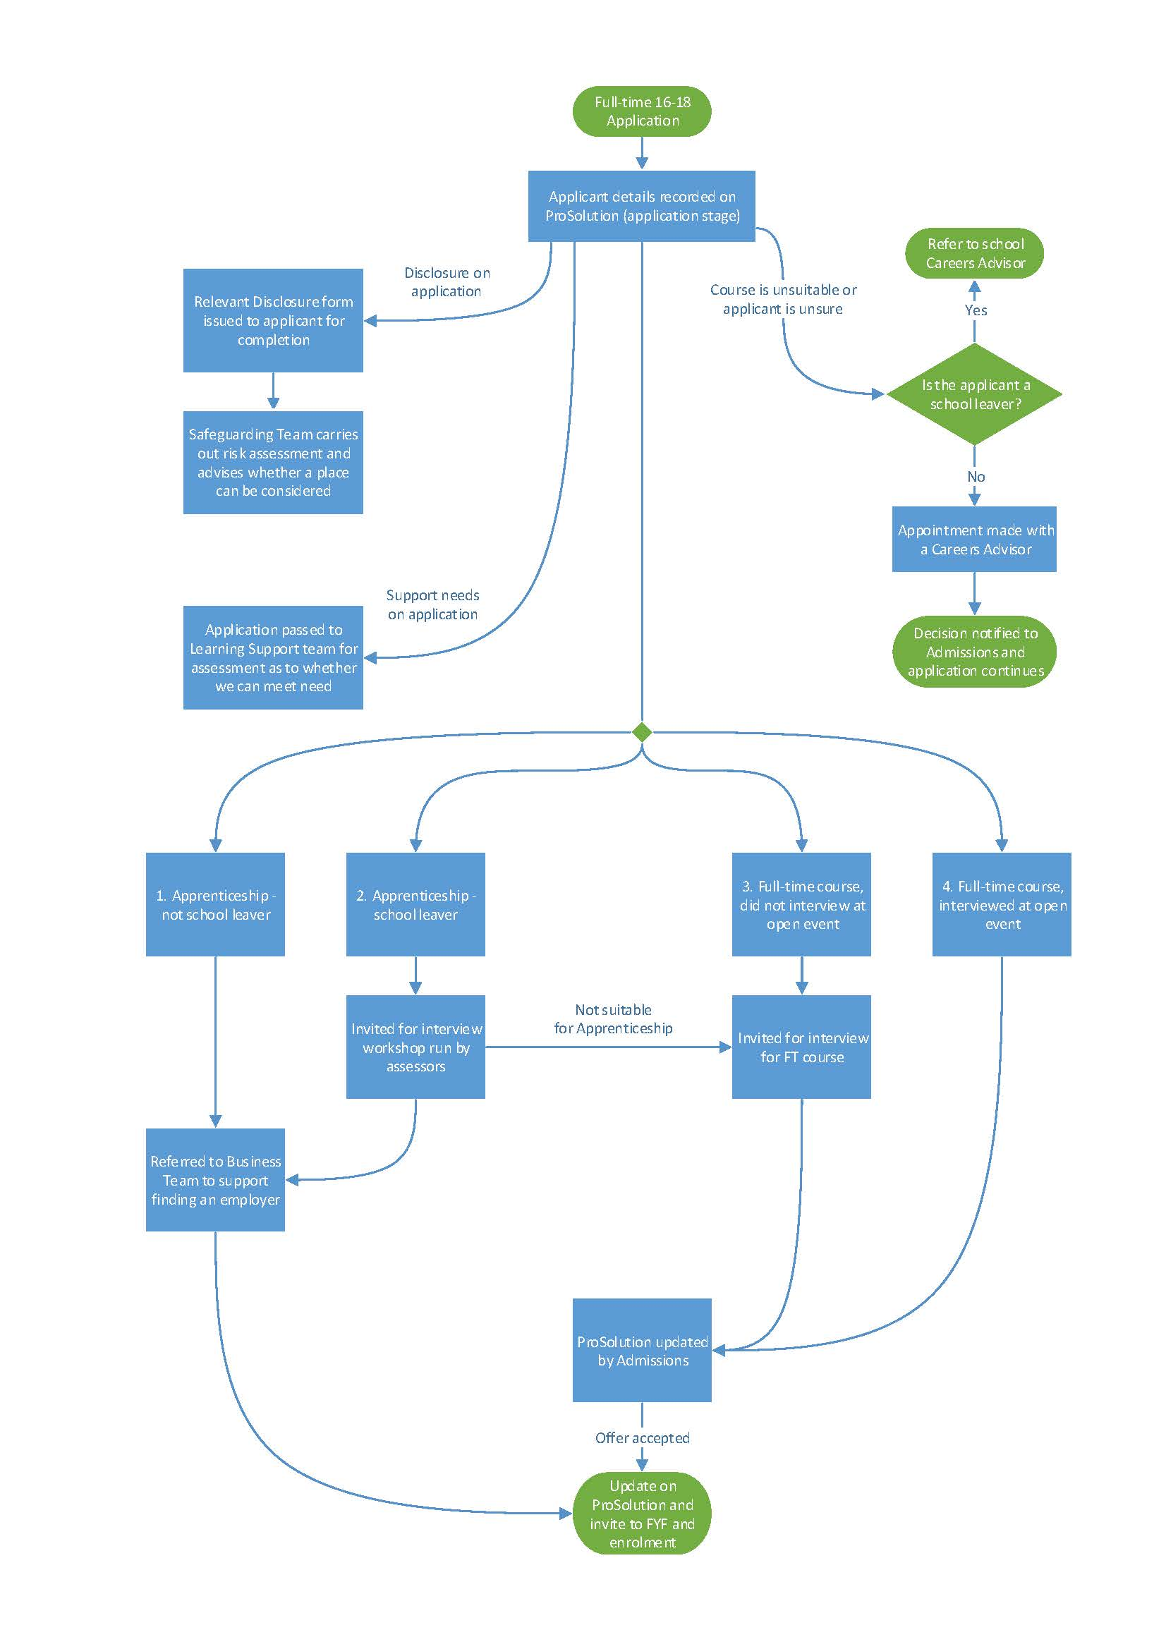

Appendix 2: Adult Admissions process flowchart

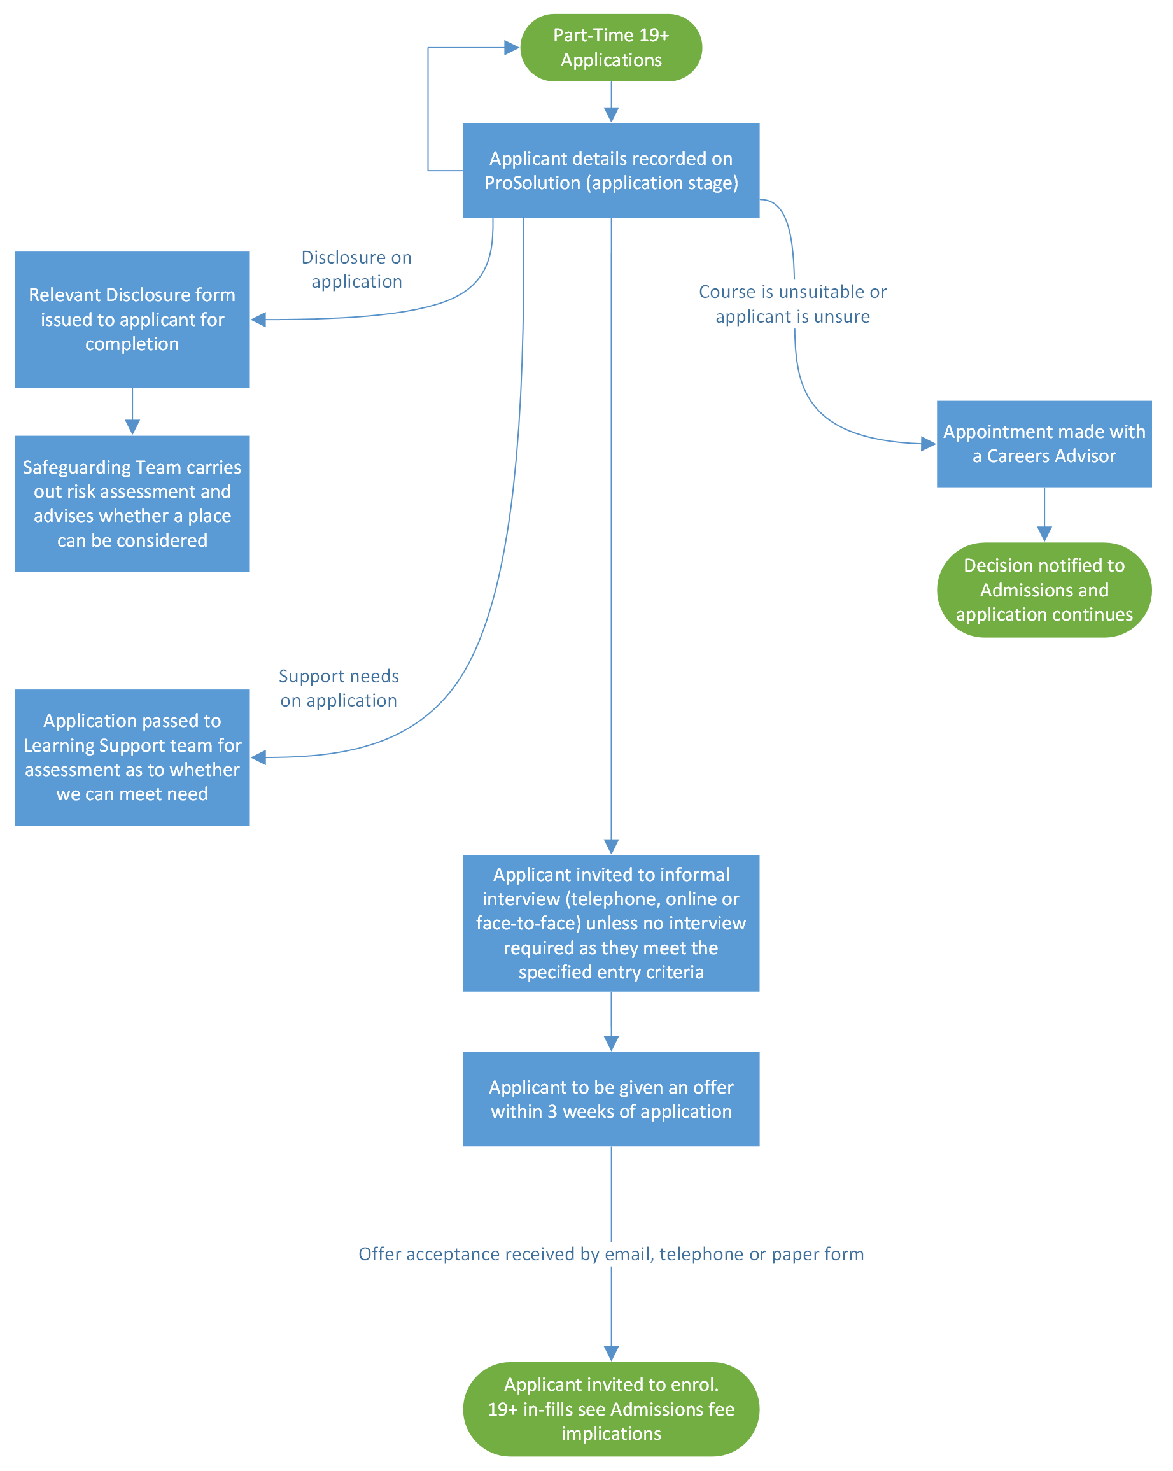

Appendix 1: HE process flowchart

